Haynes Family of Programs Welcomes you to our Annual

TRUNK or TREAT
Friday October 27th,2023
David & Margaret
Family and Youth Campus
1350 3rd street
La Verne, Ca 91750
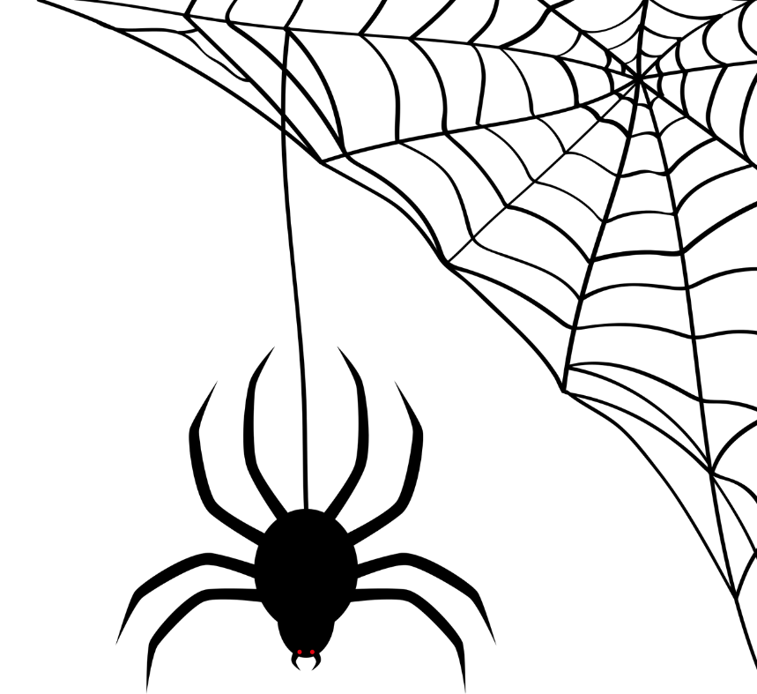         | The fun begins at 4PM  And ends at 6:00PM  Costumes not required but are encouraged!

