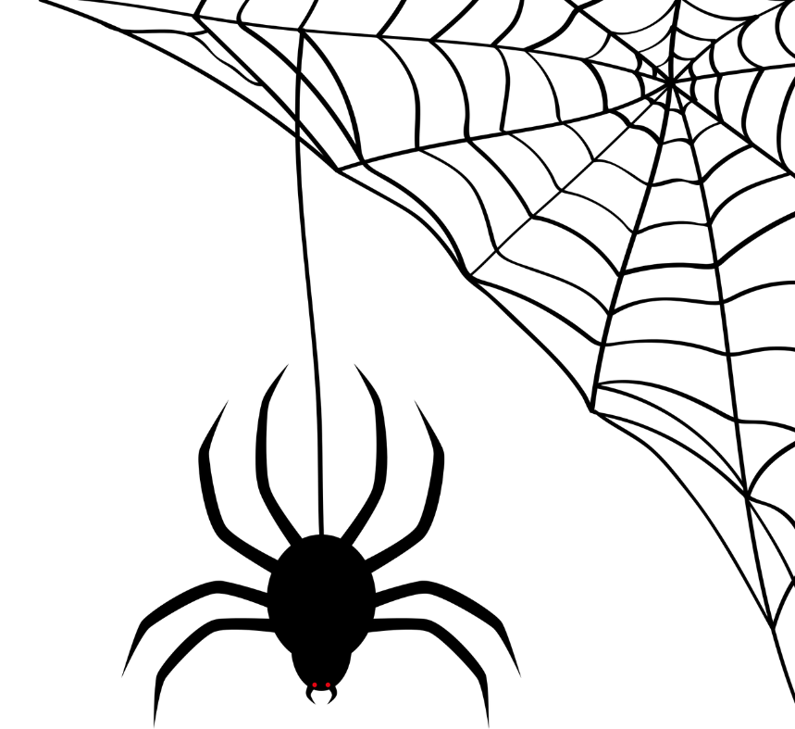

|  |  |  |
| --- | --- | --- |
| Haynes Family of Programs Welcomes you to our Annual | |  |
| TRUNK or TREAT | | |
|  | | |
| Wednesday October 30th,2024 | | |
|  |  | |
|  | David & Margaret  Family and Youth Campus  1350 3rd street  La Verne, Ca 91750 | |
|  |  | |
|  | The fun begins at 4PM And ends at 6:00PM  Costumes not required but are encouraged! | |